**Experiment 3 :**

**Combinational Circuits: Structural Modeling using Vivado**

Circuit patched on Draw.io: https://drive.google.com/file/d/1VB56FPp2V285Qg6-5Bkj7Qyl1qCUDETf/view?usp=sharing

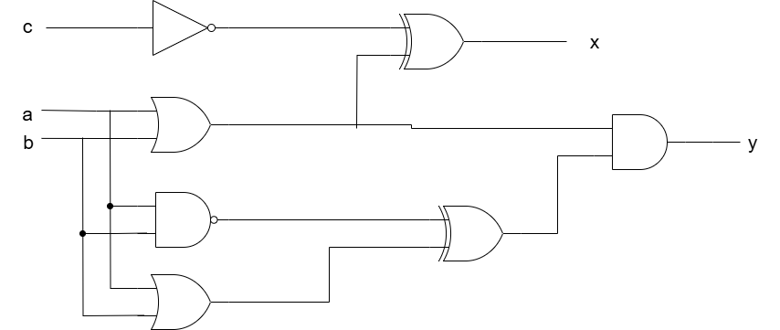

**Truth Table:**

| **a** | **b** | **c** | **x** | **y** |
| --- | --- | --- | --- | --- |
| 0 | 0 | 0 | 1 | 0 |
| 0 | 0 | 1 | 0 | 0 |
| 0 | 1 | 0 | 0 | 0 |
| 0 | 1 | 1 | 1 | 0 |
| 1 | 0 | 0 | 0 | 0 |
| 1 | 0 | 1 | 1 | 0 |
| 1 | 1 | 0 | 0 | 1 |
| 1 | 1 | 1 | 1 | 1 |

**Combinatorial Delay:**

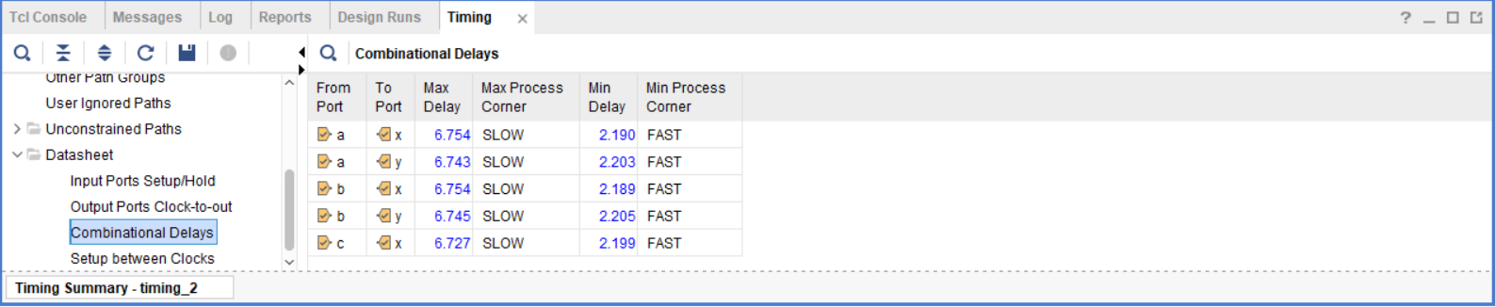

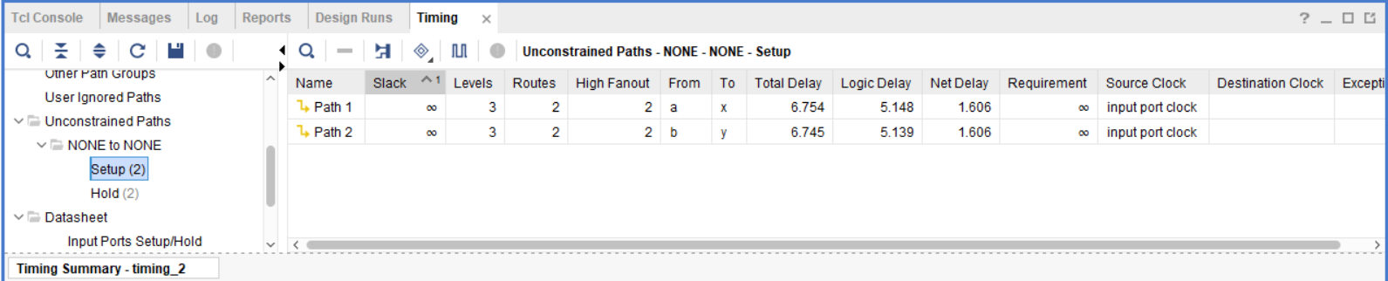

**Paths ( a to x ) and ( b to x ) have the Maximum Combinatorial Delay of 6.754s .**

**Resource Utilization:**

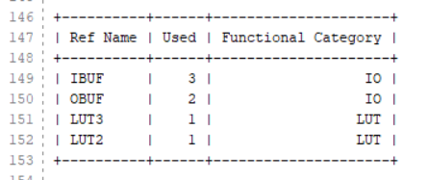

**From this report we can see that we have a total of 5 IO’s and 2 LUT’s .**